**OLSera Technical Test Documentation**

1. For the first time you need to create Database with the name olsera
2. I have been create Tax Seeder, if you want to use it, you can call by this query in terminal :

php artisan db:seed --class=TaxTableSeeder

1. Link api to call by postman for CRUD Tax :
2. POST : http://localhost:8000/api/taxes/store
3. UPDATE : http://localhost:8000/api/taxes/update
4. DELETE : http://localhost:8000/api/taxes/1
5. GET : http://localhost:8000/api/taxes
6. GET (id) : <http://localhost:8000/api/taxes/>1
7. Testing by postman :
8. POST : <http://localhost:8000/api/taxes/store>

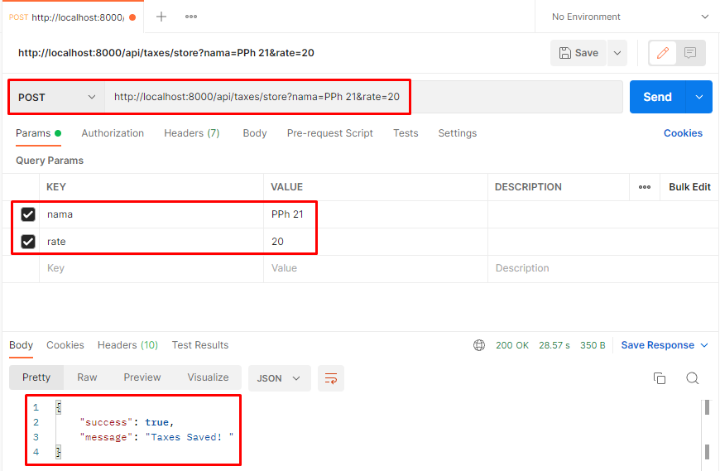

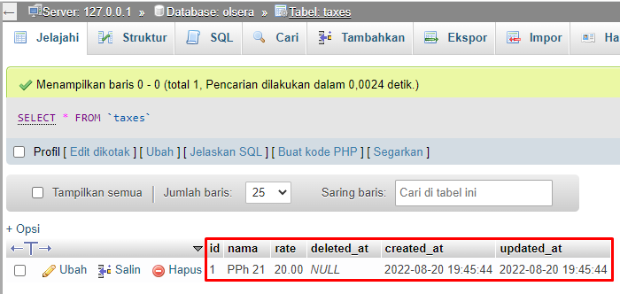

1. UPDATE : <http://localhost:8000/api/taxes/update>

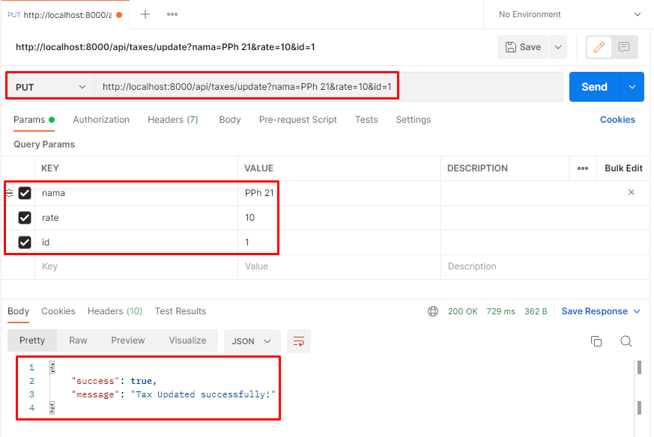

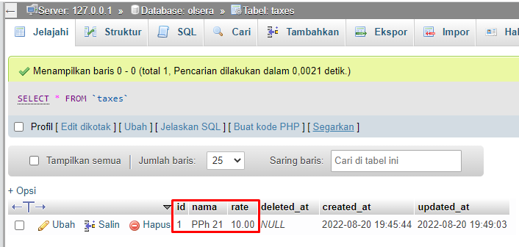

1. DELETE : <http://localhost:8000/api/taxes/1>

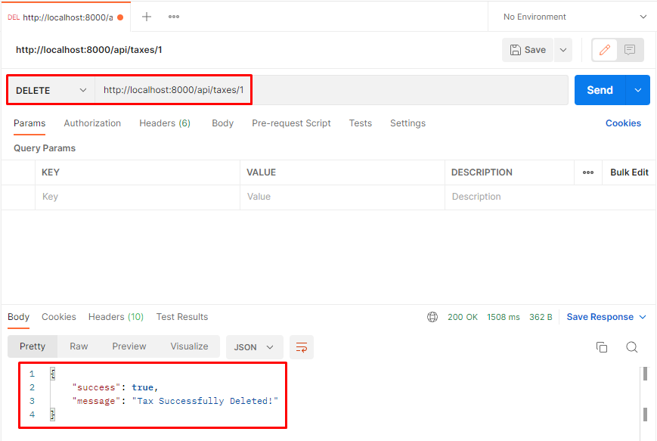

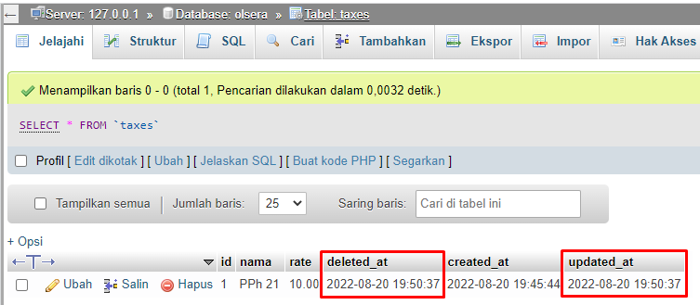

1. GET (All) : <http://localhost:8000/api/taxes>

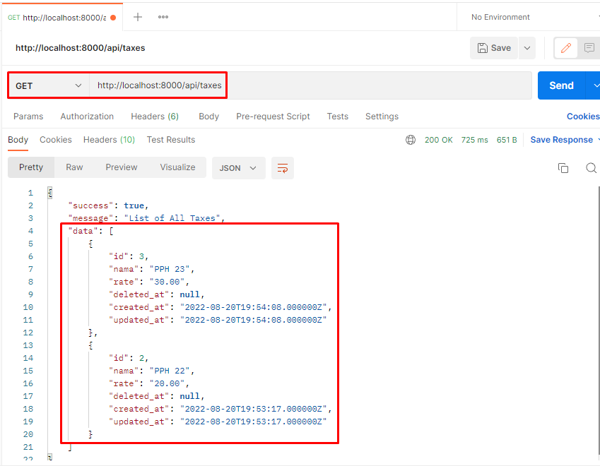

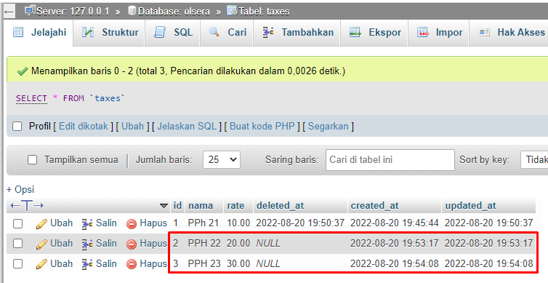

1. GET (by Id) : <http://localhost:8000/api/taxes/1>

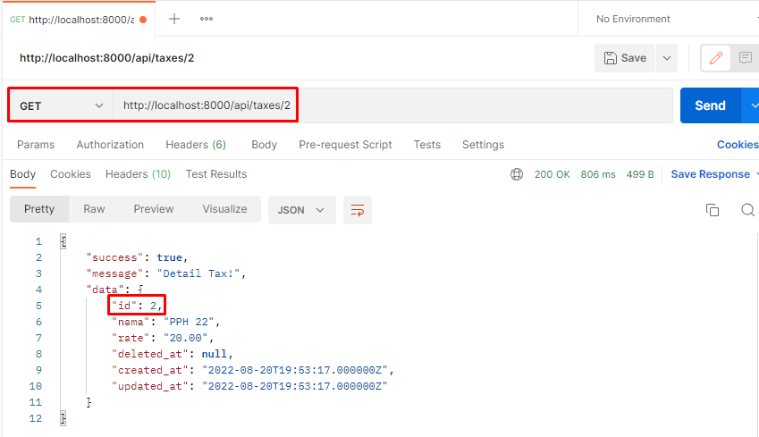

1. Link and Testing API to call by postman for CRUD Item :
2. POST : <http://localhost:8000/api/items/store>

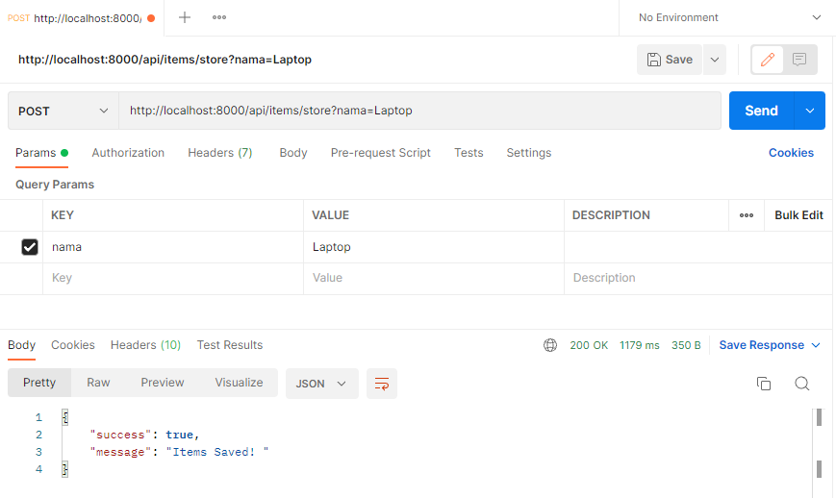

1. UPDATE : http://localhost:8000/api/items/update

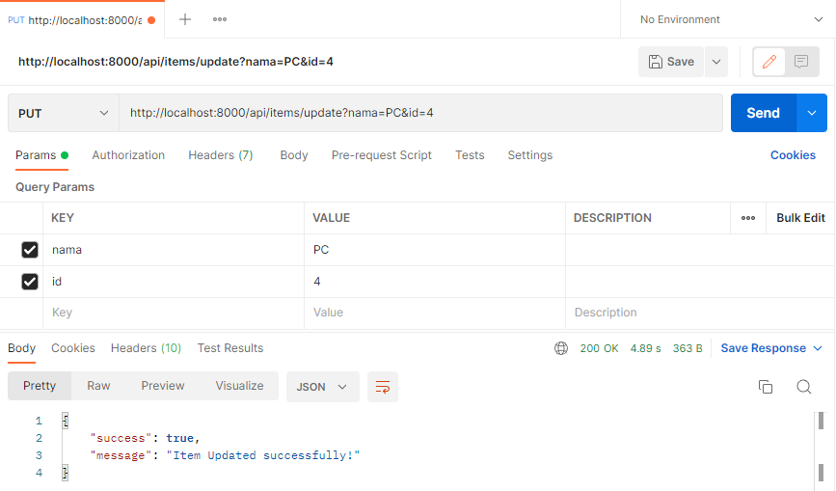

1. DELETE : <http://localhost:8000/api/items/4>

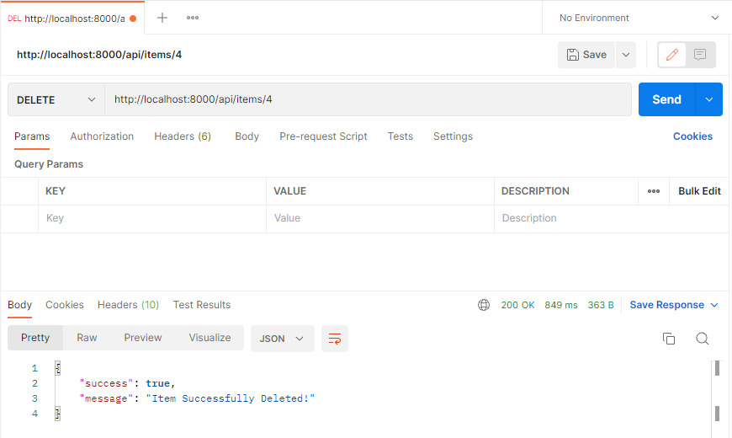

1. GET : <http://localhost:8000/api/items>

